**Prep Blog Post:**

Who is your site [for](https://muchmoreafake.com/VIDEO/Prep-Blog-Post-Video.mp4)?

Most of the time I enjoy boredom like this color.

My personal homepage is named muchmoreafake.com

I don’t feel obligated to update my personal homepage much.

Because I will be putting more time towards my self-interested pursuits.

My self-interested pursuits require periods of solitude. Which feel like this.

Friends might think the art I make during the periods of solitude is boring.

But, that is okay.

If they are bored of the art, friends might be motivated to do something else around town.

Going to a park instead, Asking themselves important questions instead, Going to visit their sisters instead.

I will be trying to stay warm during the periods of solitudes. Since, I am so bored, I can decide to take of photo of me trying to stay warm. I believe that’s what’s cool.

Thank you for listening to my presentation. I hope to be muchmoreafake.

Inspirations

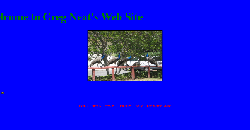<http://drneato.com/>

Classification(s): Surf Blog, Class Website, Family Photo Album.

I like this site because Dr.Neato is a kind person. He always wears a USB drive around his neck, eats Peanut Butter Jelly Sandwiches, and told me to hike in the mountains nearby.

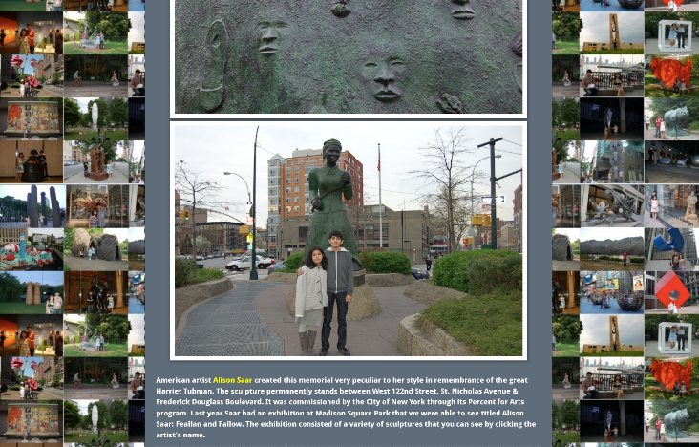<https://sculptureadventures.blogspot.com/>

Classification(s): Familial Bonding, Sculpture Archive.

I like this site because Gino & Leslie: Sculpture Obsessed Siblings are curious people. Gino and Leslie have lots of patience to visit many sculptures and write about many sculptures.

Learning and Challenge

Translating my headspace into a genuine website will be a challenge.

When I say ‘genuine website’, I mean a website that is attempting to express my personality.

I hope to not become a worse person; Making a website is difficult with my personality.

-

Michael

**Blog Post 1:**

I like flat internet things. Not pancake flat, not waffle flat, neither a cracker flat. Perhaps just into flat internet things such as what paper looks like on screens. A non-food to be exact. Paper is a non-food.

‘what paper’ looks like on screens isn’t just a photo taken of a piece of paper one can buy from an office store,

It can be a white rectangle such as the one I am typing into now. An Ultra precise (could be a lotion name) white rectangle.

Talking about what I dislike about the internet is far high in a BMI. I do not want to calculate or evaluate all the bad, cause frankly I rather be sat in a corner of a room with artificial turf and eat salmon for a minute. Then, only after having eaten I can create an airline to fly to Yugoslavia called Albatross Airlines, and the spirit animal of Albatross Airlines is the Albatross’ uncle. The uncle looks familiar to the humans, think industry film person with grey hair tied back into ponytail, plaid, jeans, ppp.

As for learning about the internet, hopefully more than a flat internet things one. Maybe eating online -a not flat internet things- will be possible instead of sat in the corner of a room with fake grass. Off to catch the flight. Will update you all after having brunch with the albatross’ uncle in NewYorkBerlin.

-

Michael

**Blog Post 2:**

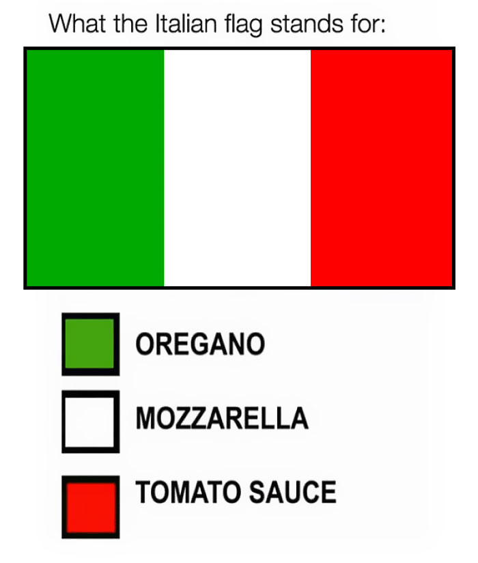I enjoy the simplicity of a flag meme.

This flag meme (e.g. ITALIAN FLAG) creates an association between a thing (TOMATO SAUCE) I might be familiar with and a colour (RED) from the Italian flag.

The association between a thing and a colour is completed, until all the colours of a(n) [insert name of a nation] flag are used.

I will ask friends if they think a flag meme helps educate themselves about a nation’s culture.

If you have opinions about a flag meme, feel free to send me an electronic mail: michael [at] muchmoreafake [dot] com. If not, talk to you next weekend.

Peace, love, and smiles.

-

Michael

**Blog Post 3 (Project 1 Closing Blog Post):**

I am so nervous about the show tomorrow. Muchmoreafake.com has allowed me the free time to arrange the logistics fooooorrr the show tomorrow.

My attention has been focused on the others involved in making the show happen. I am grateful for these others and have been tending to their time and schedules to make sure they have all the equipment and confidence to GO on SAT night to SUN morning.

I haven’t quite managed the anxiety of an upcoming event. But the website has been a place to plop photos around, while I sit hunched in my living room chair attempting to meditate. CHEW GUM faster I’m saying.

YIKES TYIKESS tike tyikess

The project has not changed since I started. Besides the infrequent updates or seldom updates idk. NOT changed in mindset. Been lugging around heavy stuff in my blue car.

I am not too worried about whether this project continues or not because it has been a side hustle (side supplement?) to my daily life. Its been funny to learn some new css tricks. Or cut around the web looking for stimuli.

FOCUS FOCUS FOCUS please focus for tomorrow, don’t be fuming, be nice and kind.

Live. Laugh. Love. I love art and the internet. I love the internet. LEARN lots love

Love

-

Michael

**Blog Post 4:**

I have a liking to use [pointerpointer.com](https://pointerpointer.com/).

Maybe, the purpose of [pointerpointer.com](https://pointerpointer.com/), is bring attention to how important our fingers are. For example, how does an index finger communicate to other people in different environments. A different environment could be taken as each time the cursor is moved to a different location a person(s) is pointing in.

The primary audience for [pointerpointer.com](https://pointerpointer.com/) could be a random passerby seeing what arbitrary domains exist out there. Maybe <https://www.pointer.com/> was too plain, so a random passerby then searchers for pointer twice: maybe [pointerpointer.com](https://pointerpointer.com/).

I am not sure about the community that uses [pointerpointer.com](https://pointerpointer.com/), but maybe it’s a random passerby who retells (word of mouth) [pointerpointer.com](https://pointerpointer.com/) to group of friends. A cave person oral thing. Maybe [pointerpointer.com](https://pointerpointer.com/) meets a desire to share cool and fun pictures on the website, that also incorporate interaction with a cursor.

My mother is not using this platform. My father is not using this platform. Based on my previous answer about the community, the cases of people using this platform seems random. Who knows there might be a group of random passerby that have somehow found each other through [pointerpointer.com](https://pointerpointer.com/).

I don’t think having a slideshow of people pointing around the screen is vulgar in any way. People pointing in the context of the photos interacting with the user (me’s) cursor when visiting [pointerpointer.com](https://pointerpointer.com/) is vibes. I like the vibe of this website, so maybe the core motive of the people who made [pointerpointer.com](https://pointerpointer.com/) is to vibe.

I think trying to also figure out who made the website, would ruin the vibe of mystery for me.

-

Michael

**Blog Post 5 (Project Concept, a Travelogue, *Tales of Döner Kebab*):**

[donerkebab.wiki](https://donerkebab.wiki/) is for learning about eating Döner Kebab around Europe. Some of the cities around Europe include, AMSTERDAM, BERLIN, COPENHAGEN, DUBLIN, EDINBURGH, FRANKFURT, GLASGOW, HELSINKI, ISTANBUL, JEREZ, KYIV, LONDON, MADRID, NICE, OSLO, PARIS, QUELUZ, ROME, STOCKHOLM, TALLINN, UTRECHT, VIENNA, WARSAW, XATIVA, YORK, ZÜRICH, A-Z an online encyclopedia. It is open to informing people about Döner Kebab restaurants in perhaps one of the cities they live in.

KEY ELEMENTS: storefronts, maps, text, a hungry stomach,

INSPO: Wikipedia deffff , Yelp but not yelp because yelp sucks, google reviews is an essential too. Pretty open to the inspo of other web platforms, but eating the Döner Kebab and the thought of eating Döner Kebab is inspiring enough.

Example:

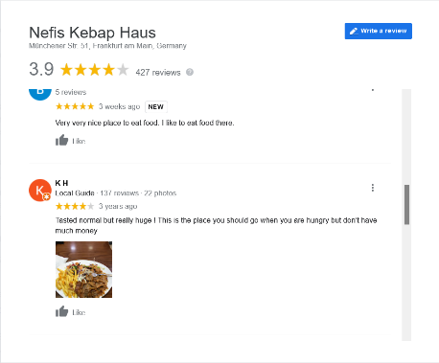

Good measurement of how not to eat or eat at the Nefis Kebap Haus.

Person one is about to eat – cyclist in AMSTERDAM, just biked a fuck ton of km from their happy apartment, needs some calories and wants Döner Kebab. Commuter kid.

Person two is about to eat – Shitty person in PARIS, just yelled at a tourist, eat something minimal today, but wants to find some food off the street, talking about a birdie, you get the message, hungry, street youths

Person three is about to eat – grandparent in LONDON, got of the tube at Piccadilly Circus, picking up food for the grandkids, and that is their favourite meal and the grandkids favourite snack, wooooooooooo

-

Michael

**Blog Post 6 (Wireframes & Mockups, a Travelogue, *Tales of Döner Kebab*):**

[link to read sitemap](https://muchmoreafake.com/sitemap.pdf)

Wireframes & Mockups pictured on the following pages:

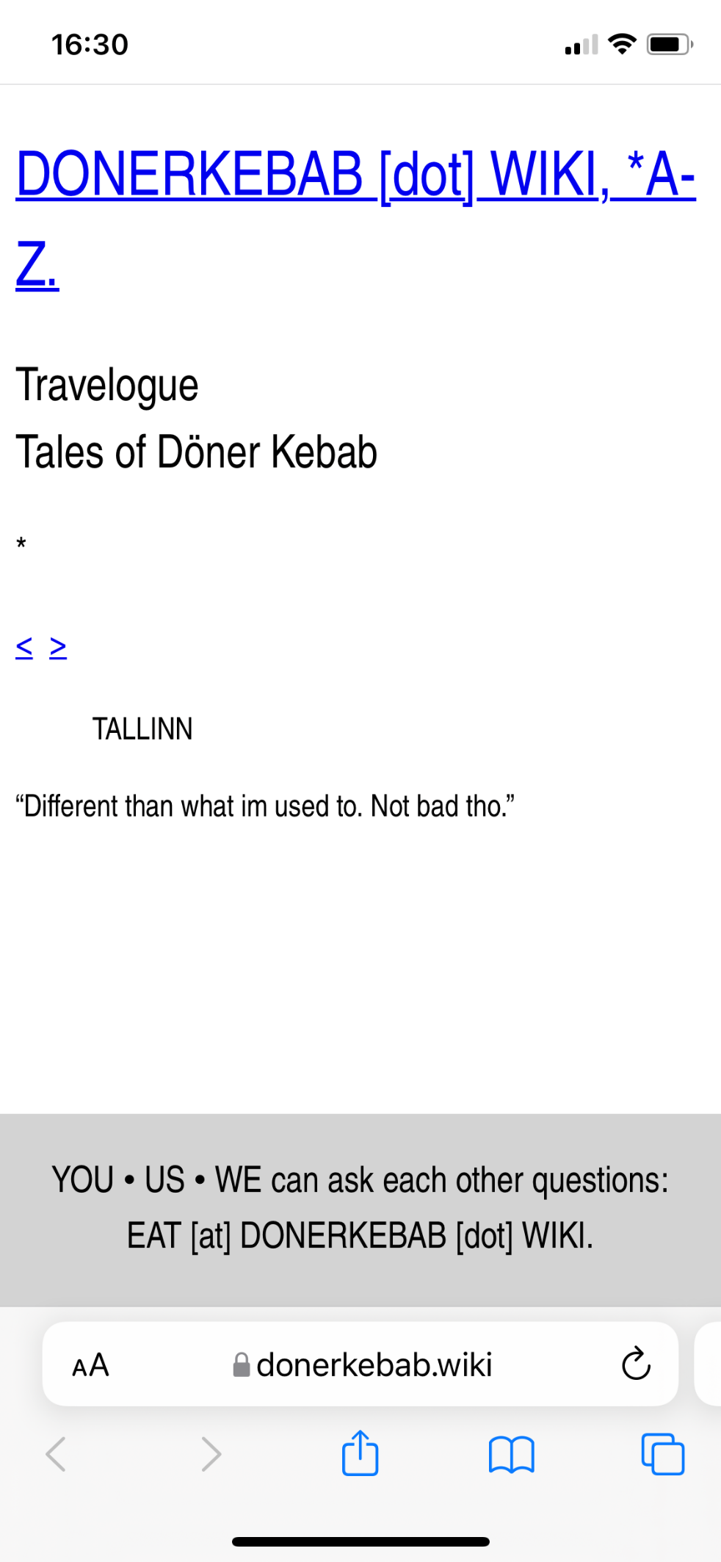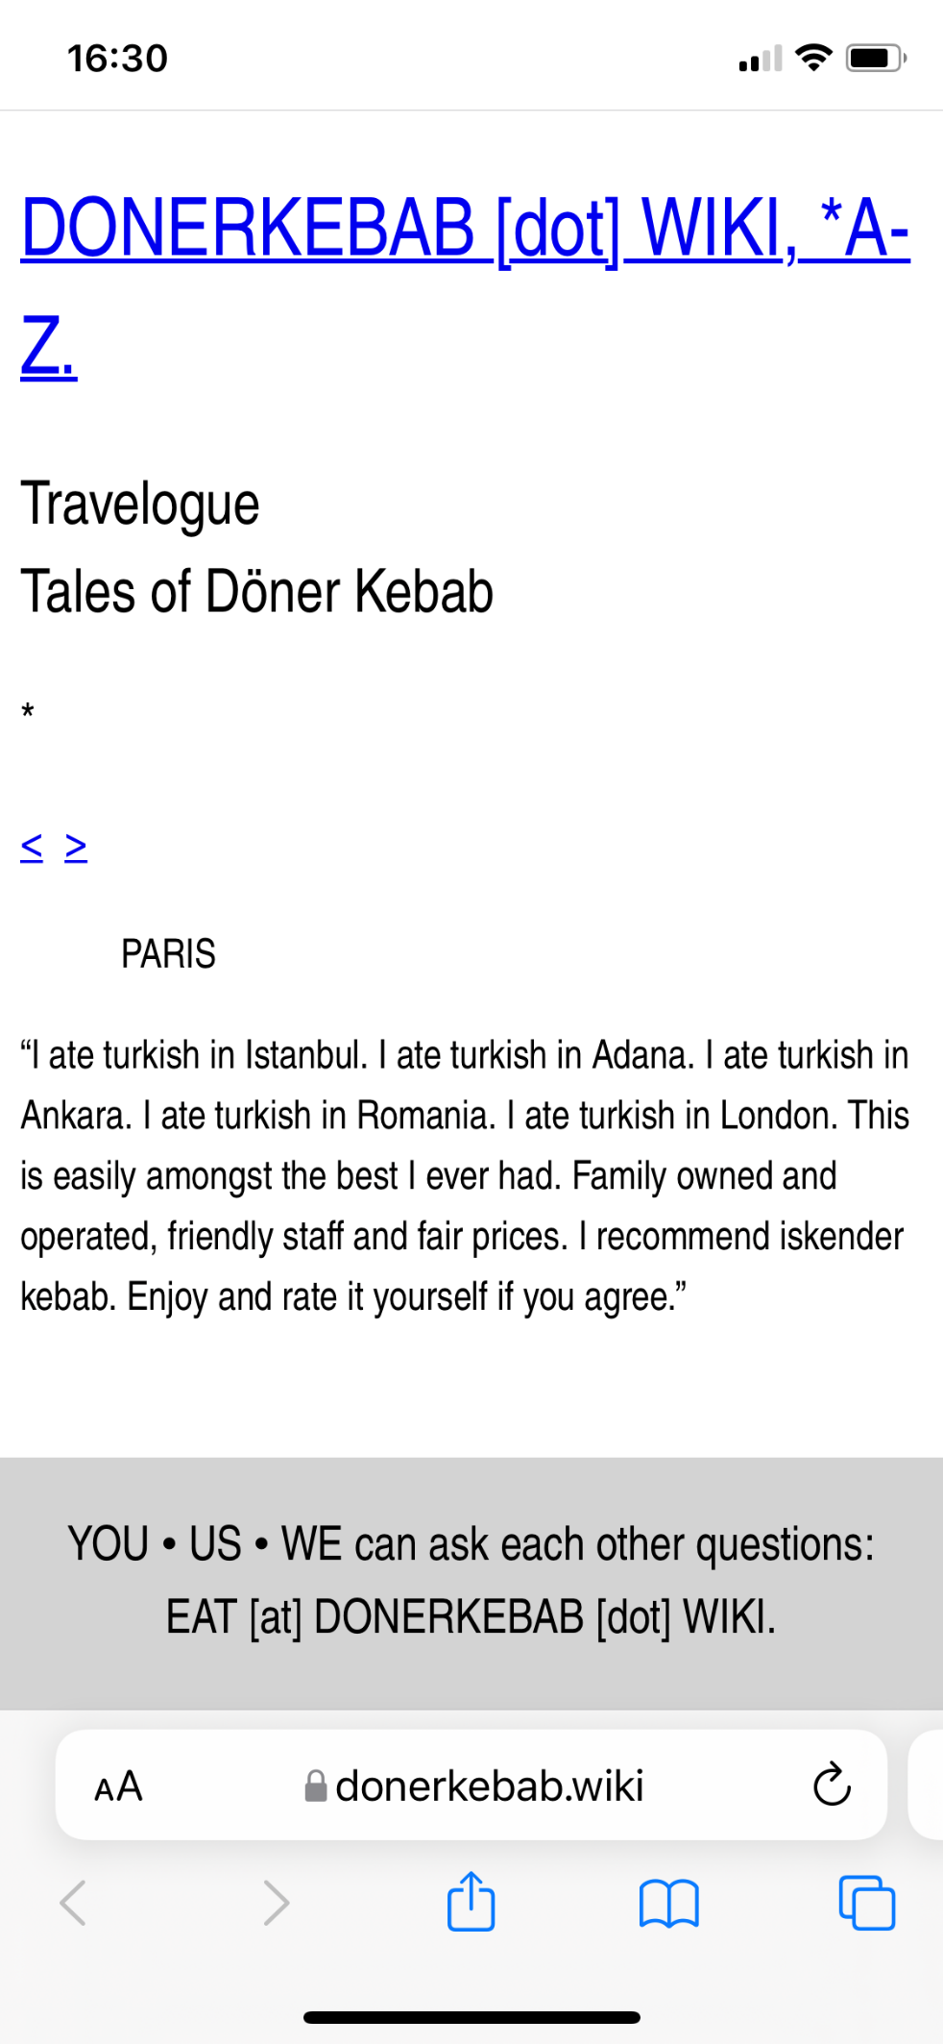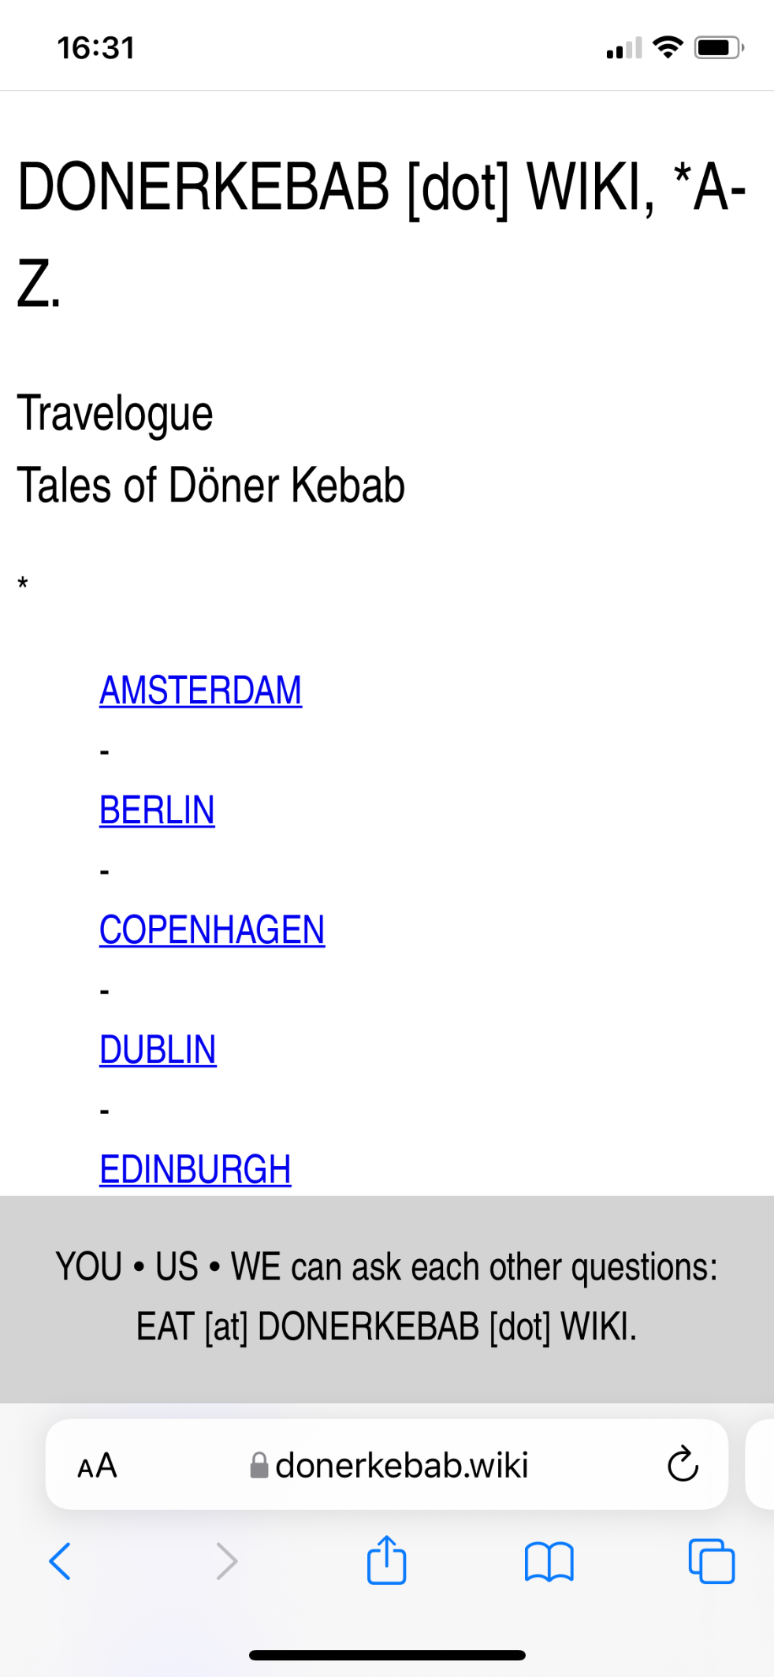

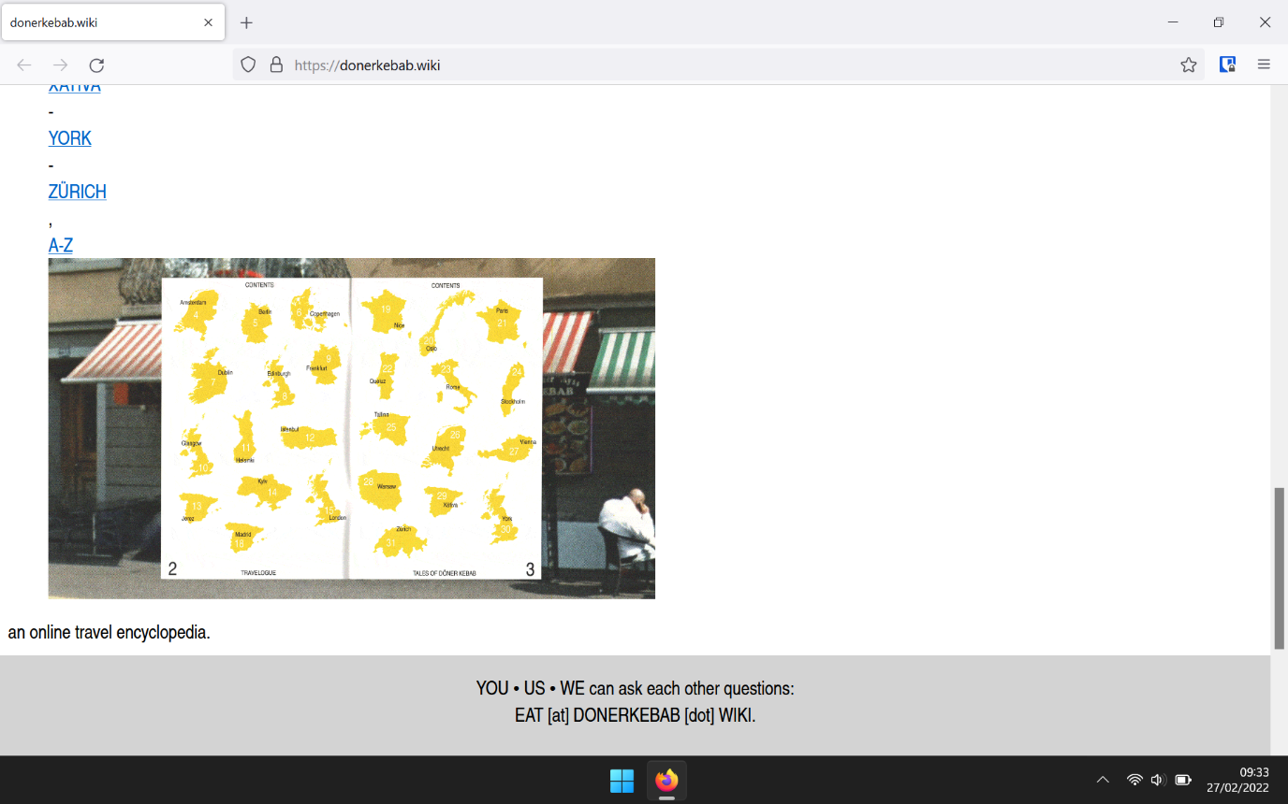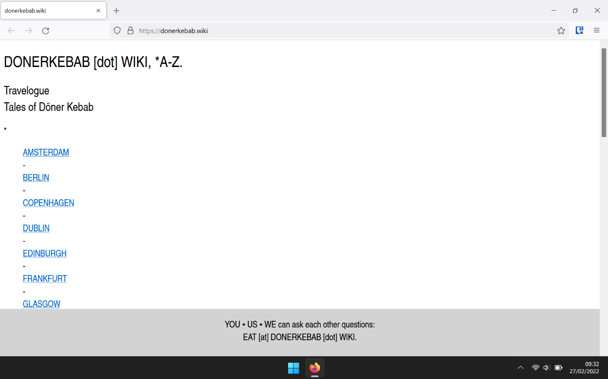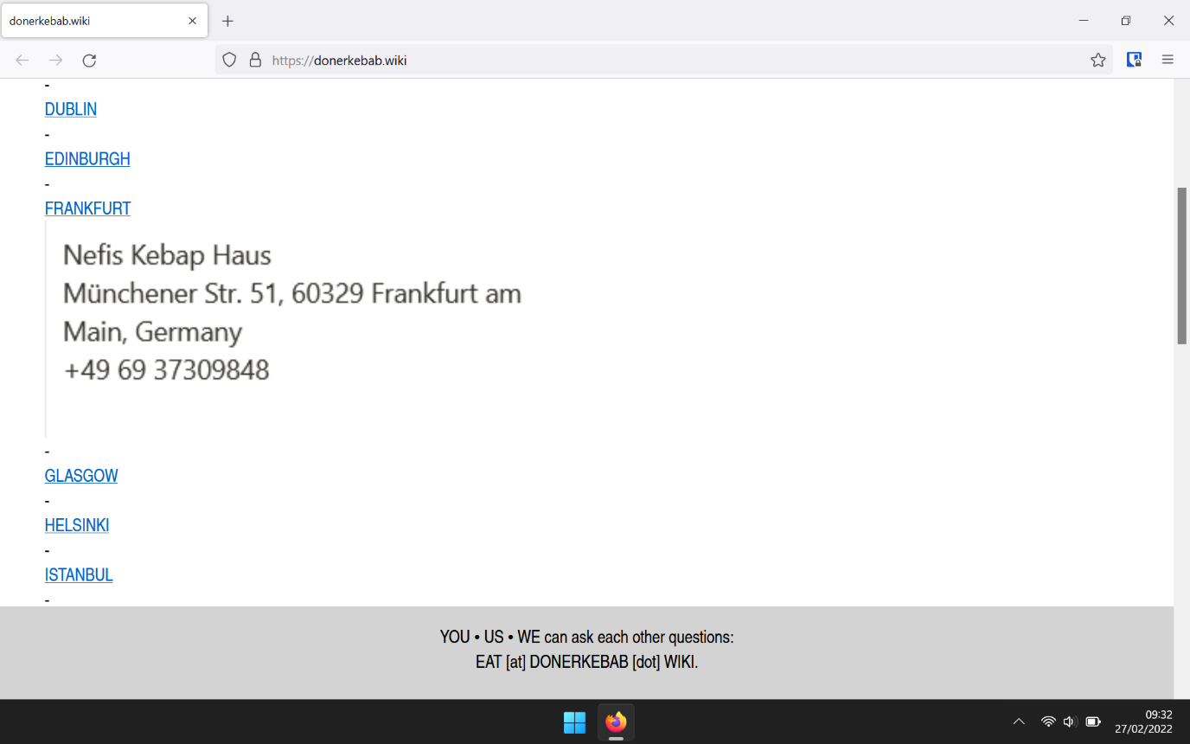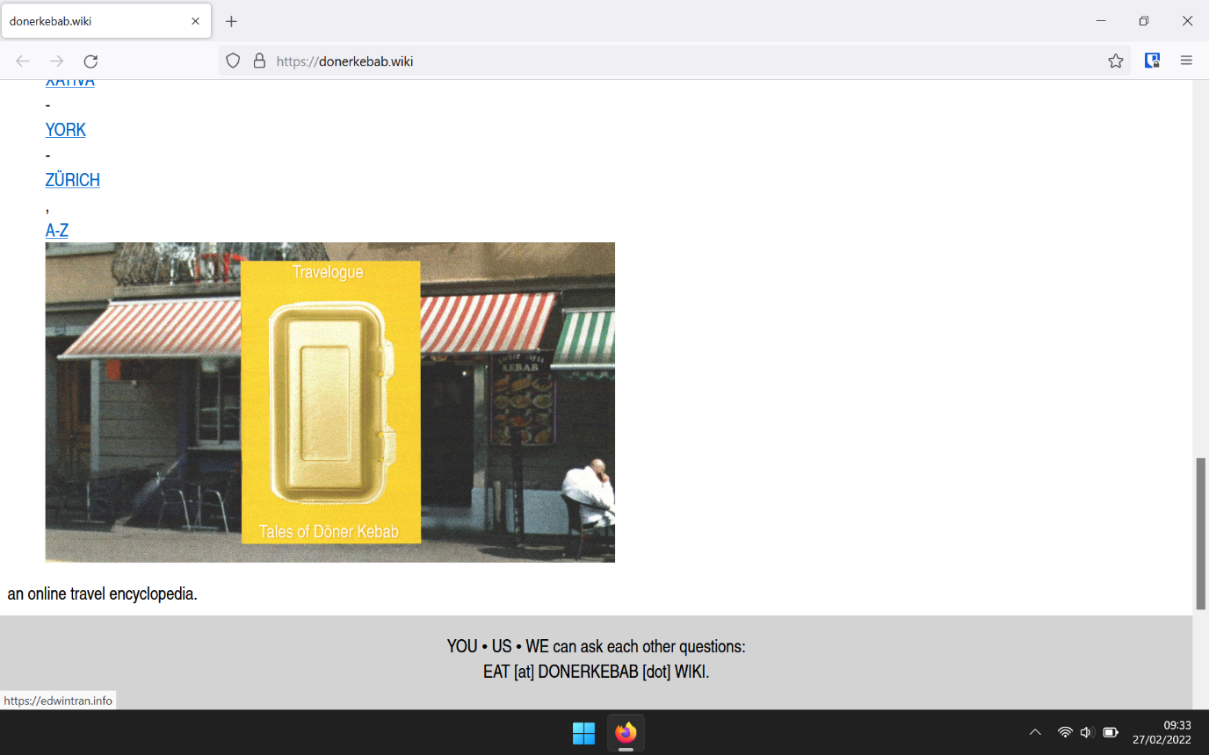

-

Michael

**Blog Post 7 (CLOSING):**

THANKS CHRIS BERIT andddddd CLASS PEERS AND FrieeeNNDSSss - Michael

